LAB ASSIGNMENT – 3
Prompt Engineering
Improving Prompts and Context Management

Name | Ch. Anirudh Bharadwaj
Roll No. | 2503A52411
Branch / Section | Batch 14

Experiment: Prompt Engineering – Improving Prompts and Context Management
1. Lab Objectives
- Understand and apply different prompt engineering techniques for generating Python programs using AI-assisted tools.
- Analyze the impact of context and examples on the accuracy and efficiency of AI-generated code.
- Develop and refine real-world Python applications through iterative prompt improvement.
2. Lab Outcomes
- Design effective prompts to generate correct and optimized Python code.
- Compare and evaluate AI-generated solutions produced using different prompting strategies.
- Implement and document real-world Python applications using AI-assisted coding tools.
3. Experiment – Prompt Engineering Techniques
Task Description: Design and refine prompts using different prompting strategies to generate Python programs for basic computational problems.
4. Question 1 – Zero-Shot Prompting (Palindrome Number Program)
Prompt:
Write a Python function that checks whether a given number is a palindrome.
Do not provide any examples. Keep the solution simple and beginner-friendly.

Generated Code:
def is_palindrome(number):
original = number
reverse = 0
while number > 0:
digit = number % 10
reverse = reverse * 10 + digit
number //= 10
return original == reverse
number = int(input("Enter a number: "))
if is_palindrome(number):
print(number, "is a palindrome.")
else:
print(number, "is not a palindrome.")

Sample Output:
Enter a number: 1001
1001 is a palindrome.

Screenshot – Q1 Program Execution
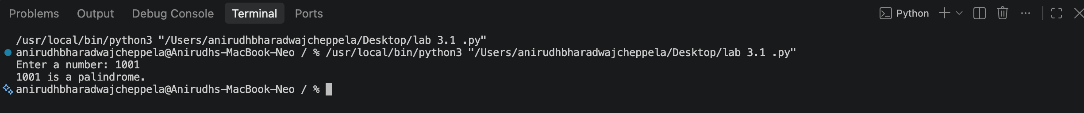

Observation: The zero-shot prompt generated a direct palindrome-checking solution without any examples. The program correctly identifies 1001 as a palindrome.
5. Question 2 – One-Shot Prompting (Factorial Calculation)
Prompt:
Generate a Python function to calculate the factorial of a given number.
Use the following example to guide the expected behavior:
Input: 5 → Output: 120.
Handle negative inputs appropriately.

Generated Code:
def factorial(number):
if number < 0:
return None
result = 1
for i in range(1, number + 1):
result *= i
return result
number = int(input("Enter a number: "))
if number < 0:
print("Factorial is not defined for negative numbers.")
else:
print("Factorial of", number, "is", factorial(number))

Sample Output:
Enter a number: 10
Factorial of 10 is 3628800

Screenshot – Q2 Program Execution
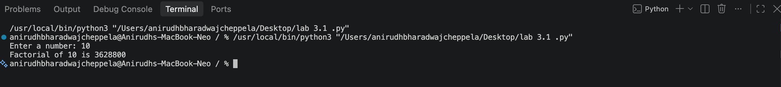

Comparison with Zero-Shot: The one-shot prompt gives the AI an explicit input-output pattern. This makes the expected result clearer and encourages the generated program to follow the specified behavior. The solution also includes negative-input handling.
6. Question 3 – Few-Shot Prompting (Armstrong Number Check)
Prompt:
Generate a Python function to check whether a number is an Armstrong number.
Use these examples to guide the output:
153 → Armstrong Number
370 → Armstrong Number
123 → Not an Armstrong Number.
Keep the program clear and reusable.

Generated Code:
def is_armstrong(number):
if number < 0:
return False
digits = str(number)
power = len(digits)
total = 0
for digit in digits:
total += int(digit) ** power
return total == number
number = int(input("Enter a number: "))
if is_armstrong(number):
print(number, "is an Armstrong Number")
else:
print(number, "is Not an Armstrong Number")

Sample Output:
Enter a number: 1000
1000 is Not an Armstrong Number
Enter a number: 153
153 is an Armstrong Number

Screenshot – Q3 Program Execution
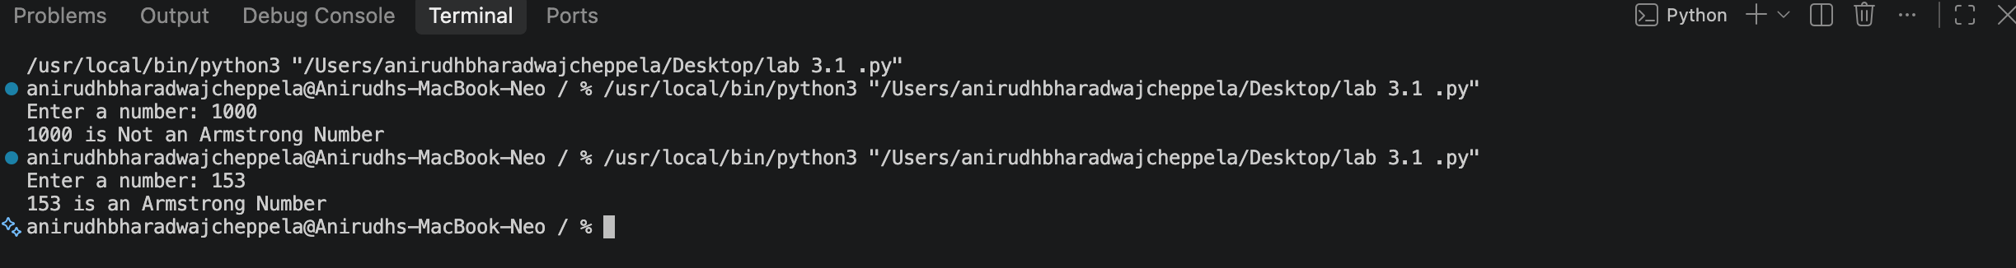

Observation: Multiple examples provide the AI with a clear pattern for both positive and negative cases. The resulting function separates the Armstrong-number logic from input and output.
7. Question 4 – Context-Managed Prompting (Optimized Number Classification)
Prompt:
Write an optimized Python program that classifies an integer as Prime,
Composite, or Neither. Validate that the input is an integer.
For efficiency, test divisors only up to the square root of the number
and skip unnecessary even-number checks. Return clear output.

Generated Code:
def classify_number(number):
if number < 2:
return "Neither Prime nor Composite"
if number == 2:
return "Prime"
if number % 2 == 0:
return "Composite"
divisor = 3
while divisor * divisor <= number:
if number % divisor == 0:
return "Composite"
divisor += 2
return "Prime"
try:
number = int(input("Enter an integer: "))
print(number, "is", classify_number(number))
except ValueError:
print("Invalid input. Please enter an integer.")

Sample Output:
Enter an integer: 17
17 is Prime

Screenshot – Q4 Program Execution
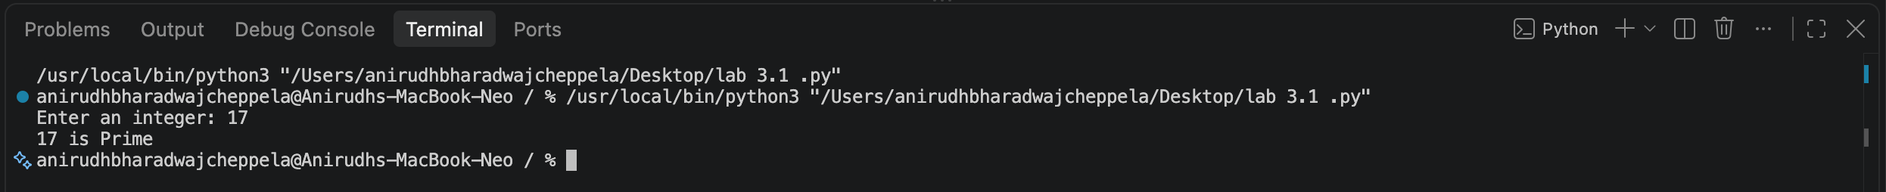

Observation: The context-managed prompt gives explicit constraints about validation and efficiency. The generated logic checks divisors only while divisor × divisor is less than or equal to the number and skips even divisors after handling 2.
8. Question 5 – Zero-Shot Prompting (Perfect Number Check)
Prompt:
Write a Python function that checks whether a given number is a perfect number.
Do not provide examples. Keep the function efficient and handle invalid
or non-positive values appropriately.

Generated Code:
def is_perfect(number):
if number <= 1:
return False
divisor_sum = 1
for i in range(2, int(number ** 0.5) + 1):
if number % i == 0:
divisor_sum += i
if i != number // i:
divisor_sum += number // i
return divisor_sum == number
number = int(input("Enter a number: "))
if is_perfect(number):
print(number, "is a Perfect Number")
else:
print(number, "is not a Perfect Number")

Sample Output:
Enter a number: 6
6 is a Perfect Number

Screenshot – Q5 Program Execution
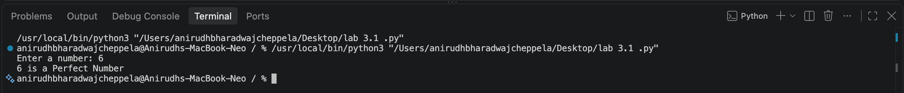

Observation: The zero-shot prompt generated a function that checks the sum of proper divisors. The square-root approach avoids checking every number up to the input value.
9. Question 6 – Few-Shot Prompting (Even or Odd Classification with Validation)
Prompt:
Generate a Python program that determines whether a number is even or odd
and validates that the input is an integer. Use these examples:
8 → Even
15 → Odd
0 → Even.
The program should also work with negative integers and clearly report
invalid non-integer input.

Generated Code:
def check_even_odd(number):
if number % 2 == 0:
return "Even"
else:
return "Odd"
try:
number = int(input("Enter an integer: "))
print(number, "is", check_even_odd(number))
except ValueError:
print("Invalid input. Please enter an integer.")

Sample Output:
Enter an integer: 7
7 is Odd

Screenshot – Q6 Program Execution
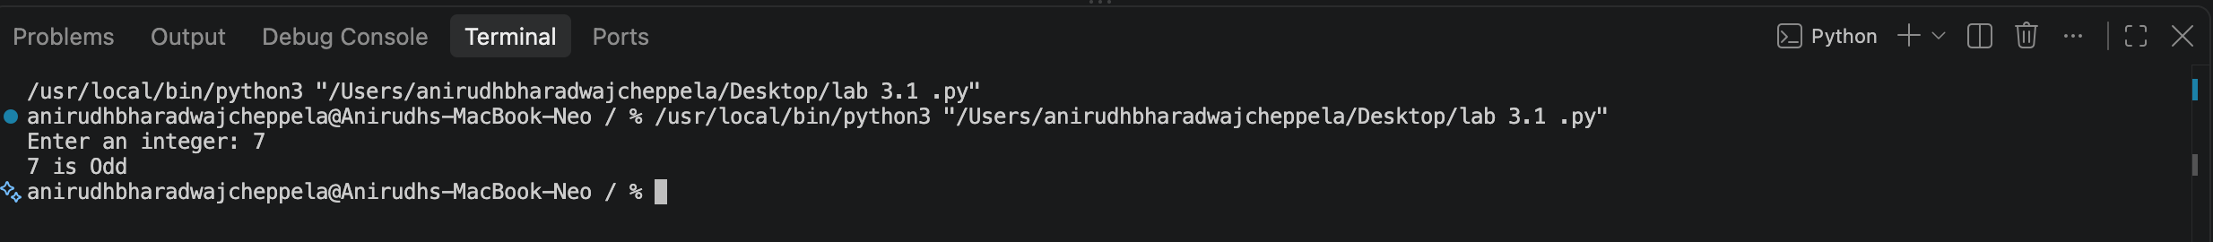

Observation: The examples establish the expected output pattern, while the additional instruction ensures validation for non-integer input. The program also handles negative integers because the modulo operation works consistently for them.
10. Overall Comparison of Prompting Techniques
Technique | Examples Given | Main Advantage | Used For
Zero-Shot | None | Tests the AI's ability to solve from instructions alone. | Palindrome, Perfect Number
One-Shot | One example | Clarifies the expected input-output behavior. | Factorial
Few-Shot | Multiple examples | Provides a stronger pattern for expected behavior. | Armstrong, Even/Odd
Context-Managed | Detailed constraints | Controls structure, validation and efficiency. | Prime/Composite/Neither
11. Conclusion
The experiment demonstrated that prompt design affects AI-generated code. Zero-shot prompting can produce useful solutions from direct instructions, one-shot prompting gives the AI one concrete example, and few-shot prompting provides multiple examples to establish a stronger pattern. Context-managed prompting provides explicit requirements such as validation, structure and efficiency, resulting in more controlled code generation.

